

**PRESIDENCY UNIVERSITY**

A Report on

**“”**

A technical project work submitted in partial fulfilment of requirement for the award of the degree of

**Bachelor of Technology**

**In**

**Computer Science and Engineering**

**By**

**Moin Ahmed Khan 20181CSE0863**

**Tannu Giri 20181CSE0847**

**Juveria Anjum 20181CSE0860**

**Mohammed Nawaz 20181CSE0853**

**Archit Kumar 20181CSE0856**

Under the guidance of

**Mr. Mohammed Mujeer Ulla M. Tech**

Assistant professor, Dept. of CSE

**Table of contents:**

1. **Aim**
2. **Components**
3. **Abstract**
4. **Introduction**
5. **Architecture**
6. **Component Connection**
7. **Code**

**8.Model Screenshot**

**9. Output Screenshot**

**Aim:** To enable a Heartbeat detection and Monitoring System using Arduino that is useful for proper monitoring of COVID-19 patients , by employing an interconnected network.

**Components:** Arduino UNO board, LCD, LEDs, 1K Resistors, Bread Board, 220 ohm Resistors, Pulse Sensor, WiFi Module ESP8266, 10K Potentiometer, Connecting Wires.

**Abstract:** The Heartbeat Detection System helps to increase patient satisfaction and reduces readmission rate in hospital. First we need to attach the Pulse Sensor to any organ of body where it can detect the pulse easily like finger. Then the Pulse Sensor will measure the change in volume of blood, which occurs when every time heart pumps blood in the body. This change in volume of blood causes a change in the light intensity through that organ. The Arduino will then convert this change into the heart beat per minute (BPM). The LED connected at pin 13 will also blink according the Heart Beat.The ESP8266 will then communicate with the Arduino and will send the data to ThingSpeak. The ESP8266 will connect the network of your router that you will provide in the code and will send the data of the sensor online. This data on the ThingSpeak will be shown in a Graph form showing the past readings too and can be accessed from anywhere over internet. The LCD connected will also show you the BPM.

**Introduction:**

In this project we are going to make a Heart Beat Detection and Monitoring System using Arduino that will detect the heart beat using the Pulse Sensor and will show the readings in BPM (Beats Per Minute) on the LCD connected to it. It will also send the readings to ThingSpeak server using the Wi-Fi module ESP8266, so that Heart Beats can be monitored from anywhere in the world over the internet. ThingSpeak is a great source for displaying the data online and you can access the data from ThingSpeak at any time and at any place.

So, using Arduino we will try to implement the system with features which will get us accurate readings as well as limit human interaction.

**Architecture:**

The connections of the LCD are as follows

* Connect pin 1 (VEE) to the ground.
* Connect pin 2 (VDD or VCC) to the 5V.
* Connect pin 3 (V0) to the middle pin of the 10K potentiometer and connect the other two ends of the potentiometer to the VCC and the GND. The potentiometer is used to control the screen contrast of the LCD. Potentiometer of values other than 10K will work too.
* Connect pin 4 (RS) to the pin 12 of the Arduino.
* Connect pin 5 (Read/Write) to the ground of Arduino. This pin is not often used so we will connect it to the ground.
* Connect pin 6 (E) to the pin 11 of the Arduino. The RS and E pin are the control pins which are used to send data and characters.
* The following four pins are data pins which are used to communicate with the Arduino.

Connect pin 11 (D4) to pin 5 of Arduino.

Connect pin 12 (D5) to pin 4 of Arduino.

Connect pin 13 (D6) to pin 3 of Arduino.

Connect pin 14 (D7) to pin 2 of Arduino.

* Connect pin 15 to the VCC through the 220 ohm resistor. The resistor will be used to set the back light brightness. Larger values will make the back light much more darker.
* Connect pin 16 to the Ground.

**CODE**

**Heartbeat Detector and Monitor code:**

The following code will start the LCD and will set the baud rate. Enter the baud rate according to your ESP8266. Every ESP8266 has its own baud rate. Some have baud rate of 9600, some have 115200 or other. *void updatebeat()* will send the data at the IP address that we have entered and also will set the data in the field we set for heart beat.

boolean connectWiFi()will connect the ESP8266 with the Wi-Fi network that you entered earlier and then it will use this network to send the data to the ThingSpeak. Then ISR()will read the sensor and will convert the output of the sensor into heart beat per minute (BPM). It will also blink the LED connected at the pin 13 according to the BPM.

**Code:**

#include <LiquidCrystal.h>

const int rs = 12, en = 11, d4 = 5, d5 = 4, d6 = 3, d7 = 2;

LiquidCrystal lcd(12, 11, 5, 4, 3, 2);

int pulsePin = A0; // Pulse Sensor purple wire connected to analog pin A0

int blinkPin = 13; // pin to blink led at each beat

// Volatile Variables, used in the interrupt service routine!

volatile int BPM; // int that holds raw Analog in 0. updated every 2mS

volatile int Signal; // holds the incoming raw data

volatile int IBI = 600; // int that holds the time interval between beats! Must be seeded!

volatile boolean Pulse = false; // "True" when User's live heartbeat is detected. "False" when not a "live beat".

volatile boolean QS = false; // becomes true when Arduoino finds a beat.

static boolean serialVisual = true; // Set to 'false' by Default. Re-set to 'true' to see Arduino Serial Monitor ASCII Visual Pulse

volatile int rate[10]; // array to hold last ten IBI values

volatile unsigned long sampleCounter = 0; // used to determine pulse timing

volatile unsigned long lastBeatTime = 0; // used to find IBI

volatile int P = 512; // used to find peak in pulse wave, seeded

volatile int T = 512; // used to find trough in pulse wave, seeded

volatile int thresh = 525; // used to find instant moment of heart beat, seeded

volatile int amp = 100; // used to hold amplitude of pulse waveform, seeded

volatile boolean firstBeat = true; // used to seed rate array so we startup with reasonable BPM

volatile boolean secondBeat = false; // used to seed rate array so we startup with reasonable BPM

void setup()

{

pinMode(blinkPin,OUTPUT); // pin that will blink to your heartbeat!

Serial.begin(115200); // we agree to talk fast!

interruptSetup(); // sets up to read Pulse Sensor signal every 2mS

// IF YOU ARE POWERING The Pulse Sensor AT VOLTAGE LESS THAN THE BOARD VOLTAGE,

// UN-COMMENT THE NEXT LINE AND APPLY THAT VOLTAGE TO THE A-REF PIN

// analogReference(EXTERNAL);

lcd.begin(16, 2);

lcd.clear();

}

// Where the Magic Happens

void loop()

{

serialOutput();

if (QS == true) // A Heartbeat Was Found

{

// BPM and IBI have been Determined

// Quantified Self "QS" true when arduino finds a heartbeat

serialOutputWhenBeatHappens(); // A Beat Happened, Output that to serial.

QS = false; // reset the Quantified Self flag for next time

}

delay(20); // take a break

}

void interruptSetup()

{

// Initializes Timer2 to throw an interrupt every 2mS.

TCCR2A = 0x02; // DISABLE PWM ON DIGITAL PINS 3 AND 11, AND GO INTO CTC MODE

TCCR2B = 0x06; // DON'T FORCE COMPARE, 256 PRESCALER

OCR2A = 0X7C; // SET THE TOP OF THE COUNT TO 124 FOR 500Hz SAMPLE RATE

TIMSK2 = 0x02; // ENABLE INTERRUPT ON MATCH BETWEEN TIMER2 AND OCR2A

sei(); // MAKE SURE GLOBAL INTERRUPTS ARE ENABLED

}

void serialOutput()

{ // Decide How To Output Serial.

if (serialVisual == true)

{

arduinoSerialMonitorVisual('-', Signal); // goes to function that makes Serial Monitor Visualizer

}

else

{

sendDataToSerial('S', Signal); // goes to sendDataToSerial function

}

}

void serialOutputWhenBeatHappens()

{

if (serialVisual == true) // Code to Make the Serial Monitor Visualizer Work

{

Serial.print(" Heart-Beat Found "); //ASCII Art Madness

Serial.print("BPM: ");

Serial.println(BPM);

lcd.print("Heart-Beat Found ");

lcd.setCursor(1,1);

lcd.print("BPM: ");

lcd.setCursor(5,1);

lcd.print(BPM);

delay(300);

lcd.clear();

}

else

{

sendDataToSerial('B',BPM); // send heart rate with a 'B' prefix

sendDataToSerial('Q',IBI); // send time between beats with a 'Q' prefix

}

}

void arduinoSerialMonitorVisual(char symbol, int data )

{

const int sensorMin = 0; // sensor minimum, discovered through experiment

const int sensorMax = 1024; // sensor maximum, discovered through experiment

int sensorReading = data; // map the sensor range to a range of 12 options:

int range = map(sensorReading, sensorMin, sensorMax, 0, 11);

// do something different depending on the

// range value:

}

void sendDataToSerial(char symbol, int data )

{

Serial.print(symbol);

Serial.println(data);

}

ISR(TIMER2_COMPA_vect) //triggered when Timer2 counts to 124

{

cli(); // disable interrupts while we do this

Signal = analogRead(pulsePin); // read the Pulse Sensor

sampleCounter += 2; // keep track of the time in mS with this variable

int N = sampleCounter - lastBeatTime; // monitor the time since the last beat to avoid noise

// find the peak and trough of the pulse wave

if(Signal < thresh && N > (IBI/5)*3) // avoid dichrotic noise by waiting 3/5 of last IBI

{

if (Signal < T) // T is the trough

{

T = Signal; // keep track of lowest point in pulse wave

}

}

if(Signal > thresh && Signal > P)

{ // thresh condition helps avoid noise

P = Signal; // P is the peak

} // keep track of highest point in pulse wave

// NOW IT'S TIME TO LOOK FOR THE HEART BEAT

// signal surges up in value every time there is a pulse

if (N > 250)

{ // avoid high frequency noise

if ( (Signal > thresh) && (Pulse == false) && (N > (IBI/5)*3) )

{

Pulse = true; // set the Pulse flag when we think there is a pulse

digitalWrite(blinkPin,HIGH); // turn on pin 13 LED

IBI = sampleCounter - lastBeatTime; // measure time between beats in mS

lastBeatTime = sampleCounter; // keep track of time for next pulse

if(secondBeat)

{ // if this is the second beat, if secondBeat == TRUE

secondBeat = false; // clear secondBeat flag

for(int i=0; i<=9; i++) // seed the running total to get a realisitic BPM at startup

{

rate[i] = IBI;

}

}

if(firstBeat) // if it's the first time we found a beat, if firstBeat == TRUE

{

firstBeat = false; // clear firstBeat flag

secondBeat = true; // set the second beat flag

sei(); // enable interrupts again

return; // IBI value is unreliable so discard it

}

// keep a running total of the last 10 IBI values

word runningTotal = 0; // clear the runningTotal variable

for(int i=0; i<=8; i++)

{ // shift data in the rate array

rate[i] = rate[i+1]; // and drop the oldest IBI value

runningTotal += rate[i]; // add up the 9 oldest IBI values

}

rate[9] = IBI; // add the latest IBI to the rate array

runningTotal += rate[9]; // add the latest IBI to runningTotal

runningTotal /= 10; // average the last 10 IBI values

BPM = 60000/runningTotal; // how many beats can fit into a minute? that's BPM!

QS = true; // set Quantified Self flag

// QS FLAG IS NOT CLEARED INSIDE THIS ISR

}

}

if (Signal < thresh && Pulse == true)

{ // when the values are going down, the beat is over

digitalWrite(blinkPin,LOW); // turn off pin 13 LED

Pulse = false; // reset the Pulse flag so we can do it again

amp = P - T; // get amplitude of the pulse wave

thresh = amp/2 + T; // set thresh at 50% of the amplitude

P = thresh; // reset these for next time

T = thresh;

}

if (N > 2500)

{ // if 2.5 seconds go by without a beat

thresh = 512; // set thresh default

P = 512; // set P default

T = 512; // set T default

lastBeatTime = sampleCounter; // bring the lastBeatTime up to date

firstBeat = true; // set these to avoid noise

secondBeat = false; // when we get the heartbeat back

}

sei(); // enable interrupts when youre done!

}// end isr

**Model Screenshot:**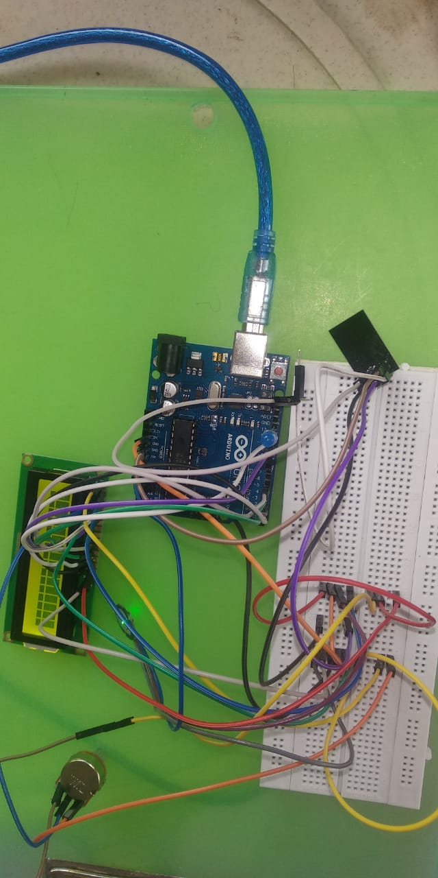

**Output Screenshot:**